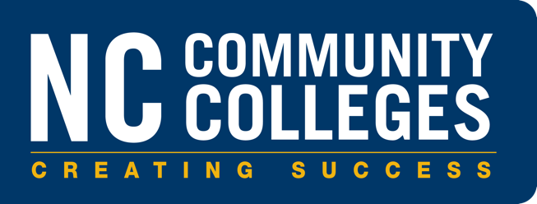

Grant Program: Expanding Community College Economic Impact

2022-23
Program Application guidelines

North Carolina Community Colleges System Office
5001 Mail Service Center
Raleigh, NC 27699-5001
NCCommunityColleges.edu

The North Carolina Community Colleges System Office reserves the right to amend this document due to, but not limited to, federal, state, or local legislation or policy changes.

Deadlines and Milestones
Milestone | Dates (subject to change)
Applications available via NCCCS RFP Website | Friday, April 8, 2022
Program Kick-Off Webinar: Webinar Link | Wednesday, April 13, 2022. 12:30-1:30pm
Applications due by email to cranep@nccommunitycolleges.edu | Friday May 13, 2022 by 5:00pm
Applicants notified of approval status | July 1, 2022 (pending Board approval on July 15)
Interim Program and Fiscal Status Report due to NCCCSO | March 3, 2023
Program and Fiscal Status Report due to NCCCSO | September 15, 2023

Contact

Dr. Patrick Crane
Vice President of Strategic Initiatives
cranep@nccommunitycolleges.edu

Allocation Program Overview
In summer 2021, Emsi Burning Glass was hired to conduct an Economic Impact Study of North Carolina’s 58 community colleges. This study, available at bigroifornc.org, documents a $19.3 billion impact and support for 319,763 jobs. This translates into a 4.5 Benefit/cost ratio for students, a 1.9 benefit/cost ratio for taxpayers, and an overall societal benefit of $7.50 for every dollar invested in community colleges. In addition to the overall economic impact, Emsi Burning Glass conducted Program Specific Economic Impact Studies for each of the 58 community colleges. These studies looked at the program specific impact for students and the state of five programs at each community college. The media student return on investment was $6.30 for each dollar a student invested in their education in one of these community college programs.
Based on the findings from the Economic Impact reports and through funding provided by the North Carolina General Assembly, the State Board of Community Colleges is establishing grant program for the 2022-2023 fiscal year. North Carolina community colleges are eligible to apply for grant funds to expand and target efforts in specific program areas that are proven to have high economic impacts in regions of the State. The State Board shall prioritize award of the grant funds based on the findings of the economic impact studies and the potential for those programs to have the greatest impact on a geographical region or region of economic development.
Resources made available through this program will support the expansion of high-impact programs by providing funding to successful applicants. This allocation program will expand the capacity of colleges to meet workforce demand in their regions and provide high return on investment for students. Funding may be used to increase faculty capacity, expand student enrollment in identified programs, strengthen employer partnerships, or better align programs with regional economic needs. Programs that are offered in partnership with another college or as part of a regional consortium are eligible for additional funding.
Programs funded through this allocation are expected to demonstrate a commitment to equity and diversity in congruence with NCCCSO's strategic plan goals and objectives.

Governing Legislation
In 2021, funding to assist community colleges to expand and target efforts in specific program areas that are proven to have greater economic impacts in their regions were appropriated through S105v8.pdf (ncleg.gov) Section 6.7.

Applicant Guidelines

Who May Apply
NC Community Colleges may apply for funding to expand or improve a high value program in the 2022-23 fiscal year.
A community college may only apply for the award of funds to support one existing program. Funds shall remain available to the community college for a period July 1, 2022, through June 30, 2023. The award of funds to a community college from the Fund shall not exceed one hundred thousand dollars ($100,000) for a proposal including one community college or one hundred and twenty-five thousand ($125,000) per college for a proposal including more than one community college. Colleges may apply for up to the maximum amounts of $100,000 or $125,000. A total of two million dollars ($2,000,000) is available and grants will be awarded until funds are expended.
If a college is not on track to expend the funds they have received by the date the Interim Report is due, unspent, unobligated funds may be redistributed.

Eligible Programs
Programs should be selected based on the results of the statewide Economic Impact Study, the college-level Economic Impact Study, or the Program-Specific Economic Impact Studies. Colleges should look at the return on investment for students, number of annual job openings, and projected growth of job openings. Programs with high ROI for students and the region will be prioritized. All of the studies can be found at BigROIforNC.org.

Application Process
Proposals must be submitted electronically through the System Office Requests for Proposal (RFPs) website/email per the deadlines outlined on page two.
A technical assistance online seminar will be held on April 13, 2022 at 12:30pm. Click on this link to access the webinar: Click here to join the meeting. You can also call in +1 984-444-6952,,420971633#.

Application Review and Evaluation Criteria
Proposals will be evaluated based on the strength of how they meet the criteria outlined in Appendix A: Evaluation Criteria. There are five primary evaluation criteria:
- New capacity for an eligible program: The proposal will expand capacity to meet student and employer demand through an existing program. Evidence shows that student recruitment and retention efforts will ensure equitable access to the offering for underserved populations.
- Timeline: The proposal lays out a timeline for implementation that demonstrates a clear path to new capacity.
- Coordination: The proposal explains how the program support students, employers, and instructors to meet a regional economic need. Attention is paid to issues of equity and diversity.
- Demonstrated labor market demand for the workers, skills, and credentials promoted by the offering, as evidenced in the Emsi Burning Glass report. Supplementary materials may also be provided to strengthen the case for economic impact.
- Potential for impact: Program selected has a high potential for impact in the community and
the budget is aligned with implementation plan and clearly supports the desired outcomes.

Complete proposals that meet minimum eligibility requirements and are submitted by the deadline described above will be evaluated by a review panel appointed by NCCCSO.
NCCCSO will make final allocation determinations based on the entirety of review panel recommendations combined with the final program and fiscal reviews. The review panel reserves the right to scale proposals as needed.
Community Colleges whose proposal meets minimum criteria may be contacted by the review panel for a question-and-answer session after the initial review process.
Applicants will be notified of their status by email.

Funding the Expanding Community College Economic Impact Grant Program
Funding for distribution is made available by S105v8.pdf (ncleg.gov) Section 6.7. Two million ($2,000,000) is made available for this program. Funding is only for the 2022-23 Fiscal Year.

Allowable Expenses
Funding is intended to expand and target specific programs with a high economic impact on their regions. Funds may be used for:
  - Faculty or staff salary and benefits that expands the capacity and impact of the program (do not supplant existing faculty salary and benefits)
  - Professional development for faculty or staff to expand or improve program
  - Student recruitment efforts that target the specific program and will increase enrollment in the program.
  - Curriculum development conducted in partnership with employers to improve program to better meet regional employer needs, including the implementation of industry-defined skill standards credentials or certifications
  - Other Instructional costs (instructional supplies, and related instructional equipment that expands programs capacity and impact).
  - Coordination with partners in a regional network
  - Facilitation or delivery of supervised paid work experiences for enrolled students.
Use of funds beyond these purposes is not prohibited but requires consultation with NCCCSO and written approval.

Proposal Overview
This funding is intended to support a net growth in a high impact program, not to supplant existing program supports.
Areas that must be addressed in the proposal are identified below. Program Information and Budget Narrative should not exceed four (4) total pages in length. Application must be sent on college letterhead and signed by college president.

Program Information & Budget Narrative
Please include the following information for the program that is the focus of your application:
- Title of program
  - Type of program
    - Credit (Certificate, Diploma, or Degree)
    - Workforce Continuing Education (WCE) Credential Aligned Course(s)
    - Aligned Industry-Recognized Credential(s), Licensure(s), Certification(s) where applicable
  - Total estimated students currently served in the program
  - Total estimated students (headcount) to be served in 2022-23 and 2023-24

In your budget narrative, please answer the following questions:
- Will these funds be used to increase enrollment, expand instructional capacity, and/or better meet employer needs in your region?
- How will the proposed activity address the identified need?
- What evidence supports the use of your identified strategy?
- How will your planned use of these funds increase the capacity of the identified program to provide an economic return on investment for students and the region?

Labor Market Demand
Please include information from your college’s Program-Specific Economic Impact Studies (PSEIS), your college Economic Impact Study, or from the statewide Economic Impact Study to demonstrate the economic impact of the program included in your application. Please consider the Career Outlook, Alumni Impact, Student Return on Investment and Taxpayer Benefit when selecting your program.

Budget
Please complete the budget template below:
Budget Template: Expanding Community College Economic Impact
 | FY23 Budget (July 1, 2023 - June 30, 2023) | Activities
Faculty or staff salary and benefits
Professional development for faculty or staff
Student recruitment and marketing efforts
Curriculum development conducted in partnership with employers
Other instructional costs
Coordination with partners
Paid work experiences for students
Total

Summary of Required Attachments
  - Attachment A: Program Description & Budget Narrative
  - Attachment B: Labor Market Demand
  - Attachment C: Budget

Appendix A: Evaluation Criteria

Part 1: Minimum Requirements to Qualify for Review
Scale: Meets or Does Not Meet Criteria. Proposals must “meet the criteria” in item 1 to be considered for funding.
Criteria | Standard | Notes
- Proposal contains all elements, Program Information and Budget Narrative are less then four (4) pages in length, application is on college letterhead, and is signed by the president. | ☐ Meets Criteria  ☐ Does Not Meet Criteria

Part 2: Proposal Evaluation Criteria
Scale: 1-5 scale where 1 represents the LOWEST possible score and 5 represents the HIGHEST possible score for each given criterion.
- Does not meet the criteria. Information is incomplete or otherwise not suitable for consideration.
- Information is present, but incomplete or inadequate for evaluation purposes. Additional detail would be needed in order to fully evaluate.
- Adequately meets the criteria and is suitable for consideration.
- Meets the criteria, provides a good amount of detail, and provides a good plan for achieving enrollment goals. Recommended for consideration.
- Exceeds the criteria, is detailed and complete, and provides a thorough plan for achieving enrollment goals. Highly recommended for consideration.
Criteria | Scale | Examples of how criteria can be demonstrated
- New Capacity for High ROI Program(s):  The proposal will expand the capacity and/or impact of an existing program that provides a high economic return on investment for students and the region. | ☐ 1  ☐ 2  ☐ 3  ☐ 4  ☐ 5 | Detail in Attachment A: Proposal, including:  - Whether the program expands capacity and/or impact of an existing program.  - Description of current program capacity and how proposed plan increase enrollment, completion, and job placement.  - A plan for recruiting students to enroll in the program. Evidence that student recruitment and retention efforts will ensure equitable access to the program for underserved populations.
- Timeline:  The proposal lays out a timeline for implementation that demonstrates a clear path to expand Career Launch capacity. | ☐ 1  ☐ 2  ☐ 3  ☐ 4  ☐ 5 | Detail in the Attachment A: Proposal:  - Steps to implement the proposal are logical, clear, and sufficiently detailed to indicate likelihood of success.  - The timeline demonstrates an understanding of the complexities of orchestrating all elements of a Career Launch program.
- Coordination:  Explanation of how program is coordinated with employers to support students, employers, and get feedback to instructors | ☐ 1  ☐ 2  ☐ 3  ☐ 4  ☐ 5 | Detail in the Attachment A: Proposal  - Description of planned coordination efforts are logical, clear, and sufficiently detailed to indicate likelihood of success  - Attention to issues of equity and diversity.
- Demonstrated labor market demand for the workers, skills and credentials promoted by the program. | ☐ 1  ☐ 2  ☐ 3  ☐ 4  ☐ 5 | Detail in Attachment B: Labor Market Demand:  - Use of Program Specific Economic Impact Study (PSEIS) findings in application.  - Strength of education-industry partnerships in program design and improvement  - Use of industry-defined skill standards for program planning, design, and improvement
- Potential for impact | ☐ 1  ☐ 2  ☐ 3  ☐ 4  ☐ 5 | Detail in Attachments A, B, and C:  - Program selected has a high potential for impact in the community.  - Budget is aligned with implementation plan and clearly supports the desired outcomes.

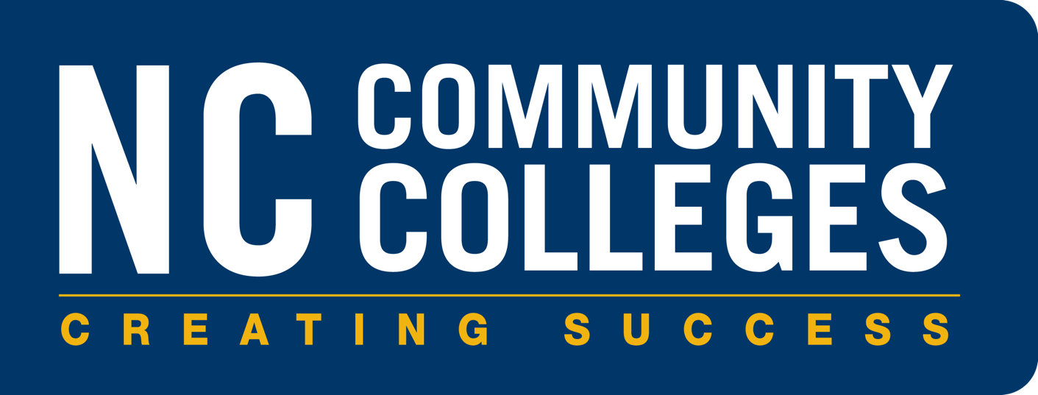

CC BY 4.0, unless otherwise noted.
North Carolina Community College System

