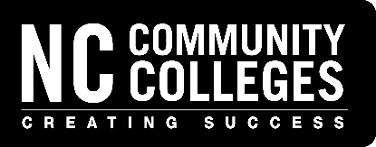

NC Division of Motor Vehicles
Vehicle Safety and On-Board Diagnostics (OBD) Emissions

Registration Form
2022 Instructor Certification Training

DMV Vehicle Inspection Certification Coordinator - Contact Information

Coordinator’s Name:

Community College:
Phone Number:

Email Address:

To register your instructors, please specify their name(s) and desired date(s) in the space below:

Attendee’s Name/Email | Wake Tech |  |  | Central Piedmont |  |  | Pitt |  |  | Fayetteville Tech |  |  | Central Piedmont |  |  | Wake Tech
 | Safety | OBD |  | Safety | OBD |  | Safety | OBD |  | Safety | OBD |  | Safety | OBD |  | Safety | OBD
Example: Jane Doe  janedoe@email.com | Mar  9 | Mar  10 |  | April 6 | April 7 |  | May 11 | May 12 |  | June 8 | June 9 |  | Aug 3 | Aug 4 |  | Oct  5 | Oct 6

All training classes will be held 8:30 a.m. – 5:30 p.m. at the college indicated.
Inspectors from the License and Theft Bureau, Division of Motor Vehicles,
North Carolina Department of Transportation will instruct the classes.

Complete this registration form and send it as an email attachment to Temeka Hester

tikkanenk@nccommunitycolleges.edu

