# CCR Employment Barrier-Data FAQ

1. Our understanding was that only ESL students and students at the two lowest ABE placement levels would qualify as ELLCB. Are we now to flag all, including AHS and HSE students at ASEL or ASEH placement?

**Response:**

Yes, please flag all students who are eligible to be served in Title II with the ELLCB designation.

1. Do we add ELLCB even if students have another barrier indicated.

**Response:**

Yes, please flag all students who are eligible to be served in Title II with the ELLCB designation.

1. You cannot submit the period 12 (final) flat file unless all errors are cleared, so you would have to enter the ELLCB designation, correct?

**Response:**

Yes, you will not be able to submit the period 12 (final ) flat file until all errors have been corrected. Please flag all students who are eligible to be served in Title II with the ELLCB designation

1. Can colleges view their error reports in Power BI?

**Response:**

Yes. If you need assistance in using the Power BI tool, please submit an incident ticket through ServiceNow.

1. Where do I go in Datatel/Colleague to ensure faculty is listed as an instructor?

**Response:**



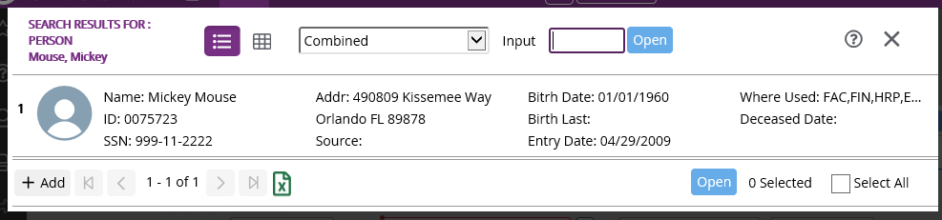

1. Are students who are post tested between the dates of June 15-June 30th counted in the current program year MSG data? (If you have run XLEULT)

**Response:**

Yes, if a student is post-tested between the dates of June 15- June 30th they are counted in the current program year, as long as the college has not processed XLEULT for the new reporting year.

XLEULT is only opening up tests for the new reporting year.

1. I was told without social security numbers we would not receive Federal funding, but we can receive State funding.

**Response:**

Having a social security number is not a requirement for receiving services from Title II.

1. If a student does not have a social security number will that hurt post-test gains?

**Response:**

Having a social security number is not a requirement for receiving services from Title II. However, social security numbers are used by the Research Performance Management (RPM) office for data matching to track and report gains (i.e., data wages, etc.).

1. Is the System Office tracking students who do not have a social security number?

**Response:**

The System Office tracks all students.

1. Is there any future training on entering time for self-service?

**Response:**

Training is forthcoming from the System Office IT.

**Additional Resources**

For additional information on Employment Barriers please consult the following resources:

NRS Training [“Employment Barriers”](https://nrsweb.org/training-ta/barriers-employment)

Technical Assistance Guide for Performance Accountability under the Workforce Innovation and Opportunity Act (2021)

LEIS Form Data Dictionary (accessible via the NCCCS website, Program Quality & Accountability page)