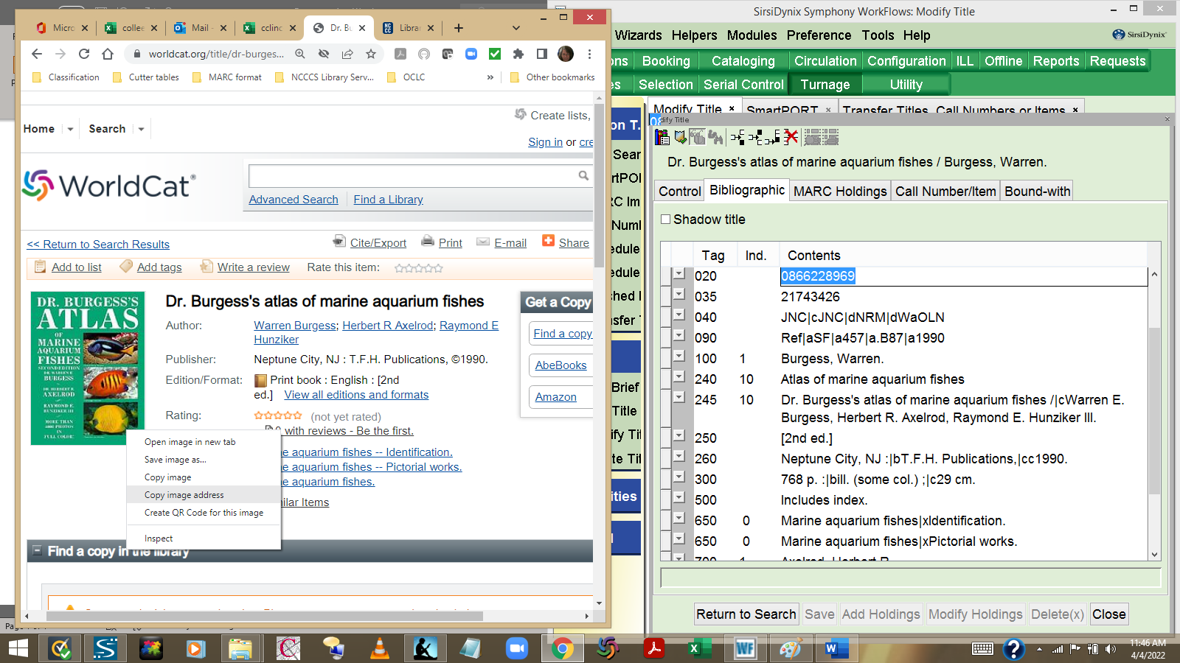
- Right click on the book jacket cover image in WorldCat and select Copy image address.

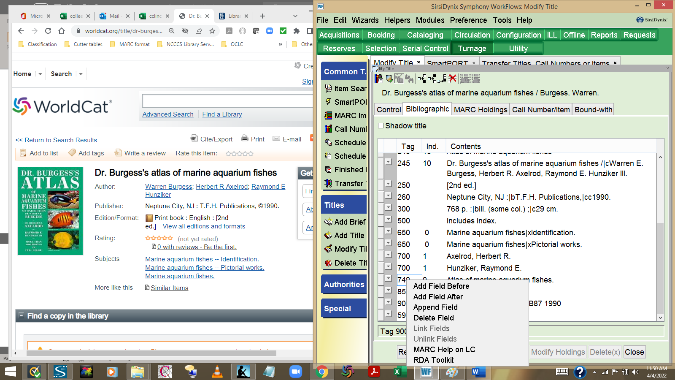
- Scroll down MARC record in SmartPort (for the record you’re importing to the catalog). Right click and select Add Field After.

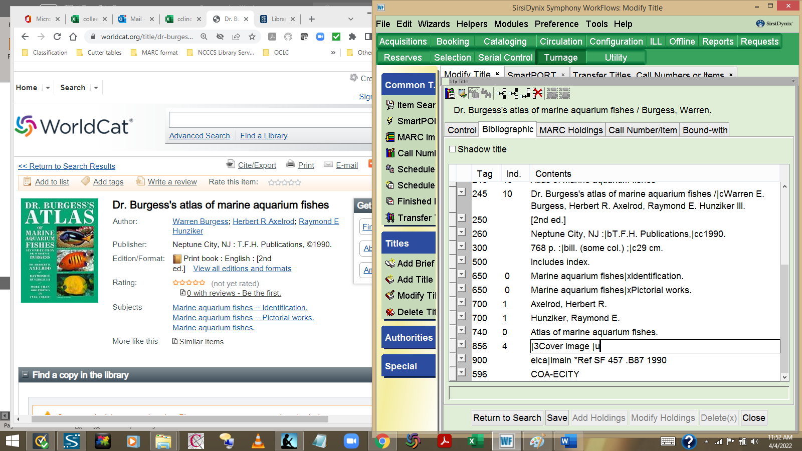
- Enter the MARC tag # 856. Tab to the next field and enter the first indicator 4. Tab to the next field and enter |3Cover image |u as shown in the screen shot above.
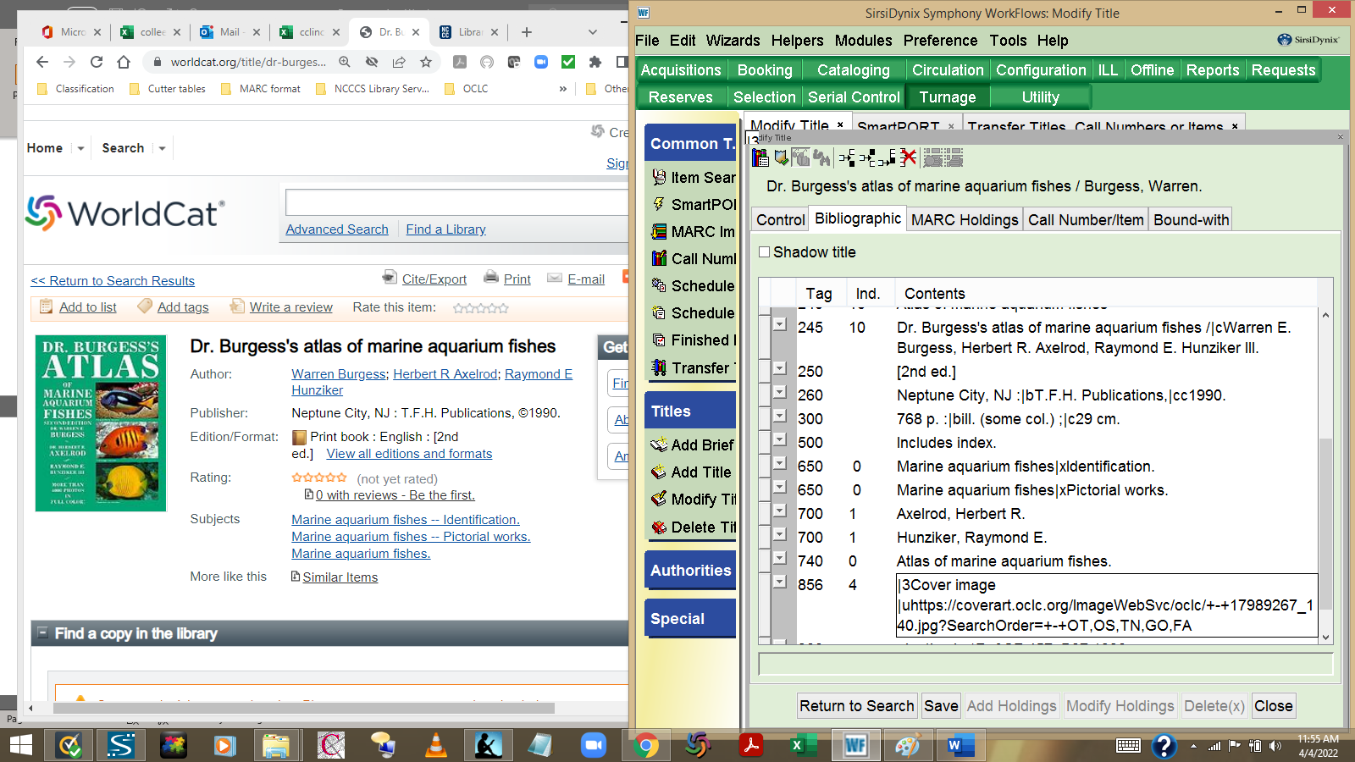
- Use the CTRL-V command to paste the image address in the 856 field you have created.
- Click on Save and Close buttons when done. The book jacket cover you have added to the record will display in the OPAC the following day.

