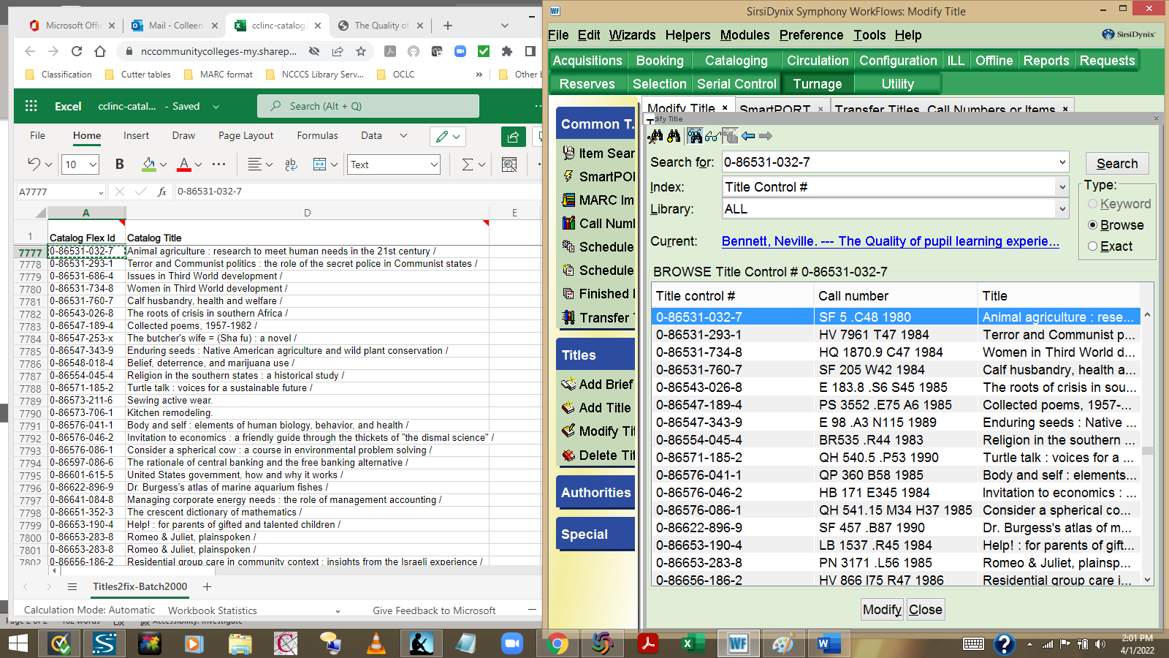
You’ll need to display your list displayed on one side and have WorkFlows open on the other for this. You will also need to have WorldCat open. I recommend that you use the following wizards: Modify Title, SmartPort, and Transfer Title (as shown in the screen shot above). Modify Title wizard’s Properties should be set to BROWSE by Title control #. Click on the Configure Options helper and select “No” for Shadow under the Search tab. This eliminates any titles that are in shadowed locations (ex. DELETEME, DISCARD). The Transfer Wizard Properties should be set to do an EXACT search by Title Control #. Enter the first non-OCLC Title control # from your list in the WorkFlows Modify Title search box. (You can use helpers to click on the Show/Hide View Pane button so that only your Search and List panes display, as shown above in the screen shot). Highlight and double-click on the first title in WorkFlows to start!
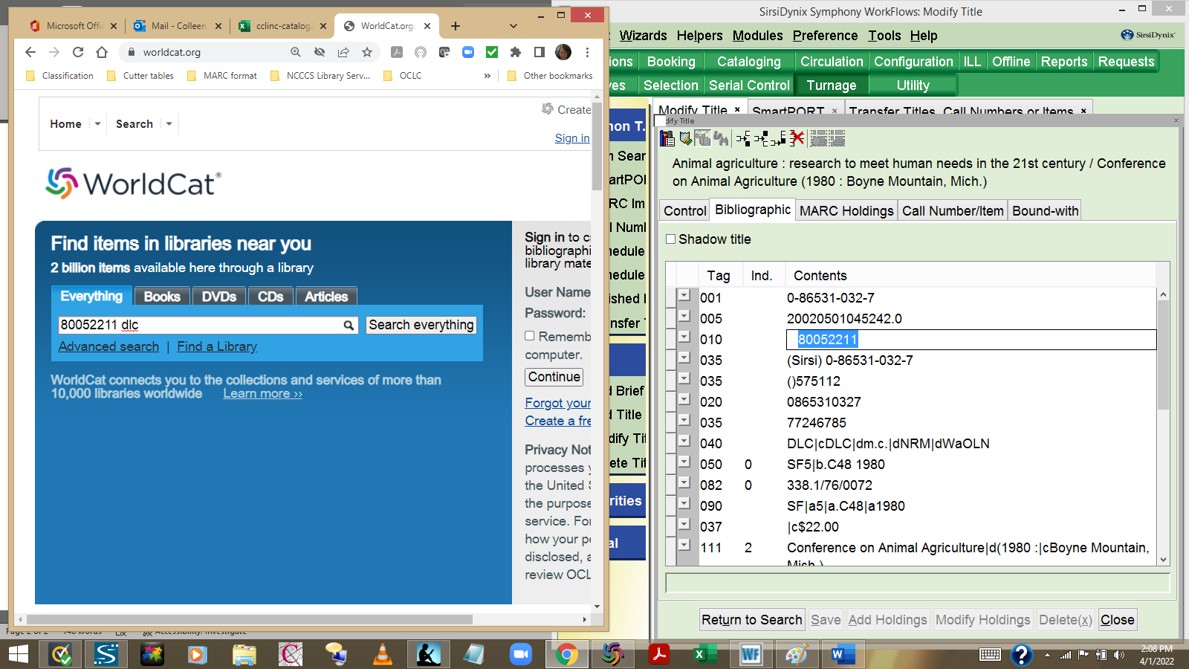
Double click on the LCCN in the 010 field and use CTRL-C to copy the #. Then use CTRL-V to paste that # in WorldCat. Add dlc at the end so that you’ll pull up DLC (Library of Congress copy). Use the ISBN as your search key if there is no LCCN present in the record. Do a combination keyword search (ex. Keywords from title AND publisher name AND year published) if there are no numeric search keys present in the record.

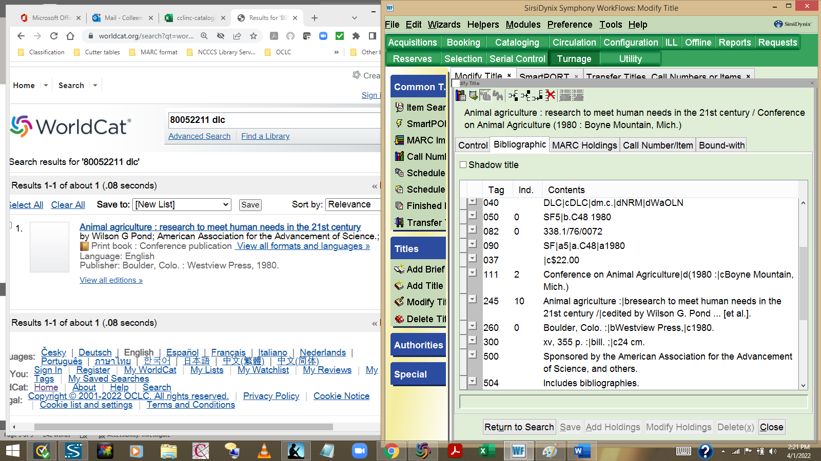
Check to be sure the title, publisher, and date match the record in WorkFlows. If they match click on the hyperlinked title in WorldCat to view the entire record.

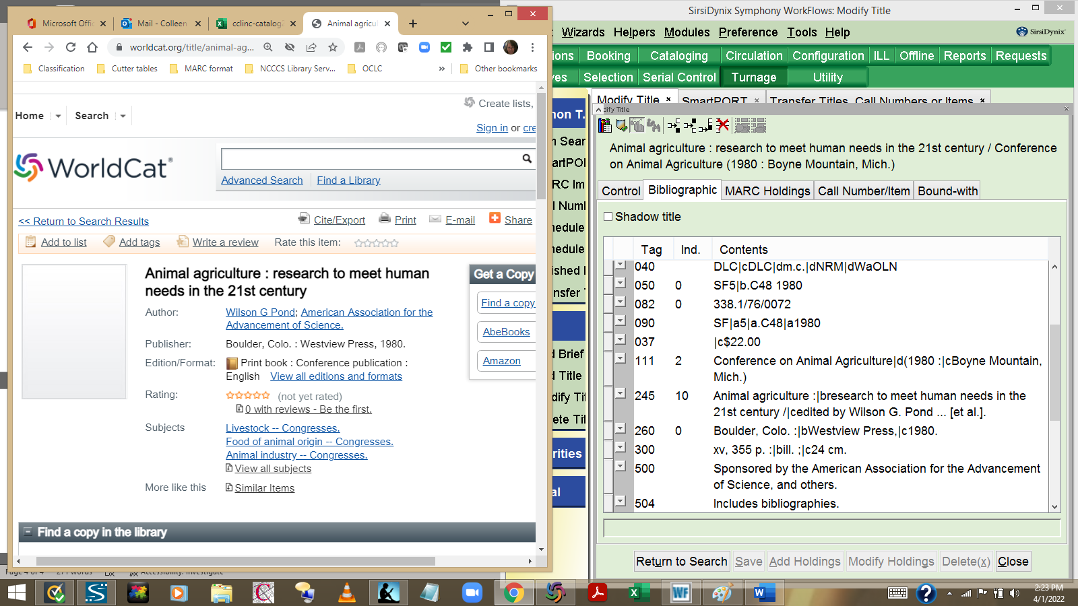
If your title in WorkFlows includes an edition statement (Note that this example does not), then you would find the edition statement noted on this detailed display in WorldCat. You’ve already verified the title, publisher, and date. Now you need to scroll down the WorldCat screen to view the Details and get your OCLC#.

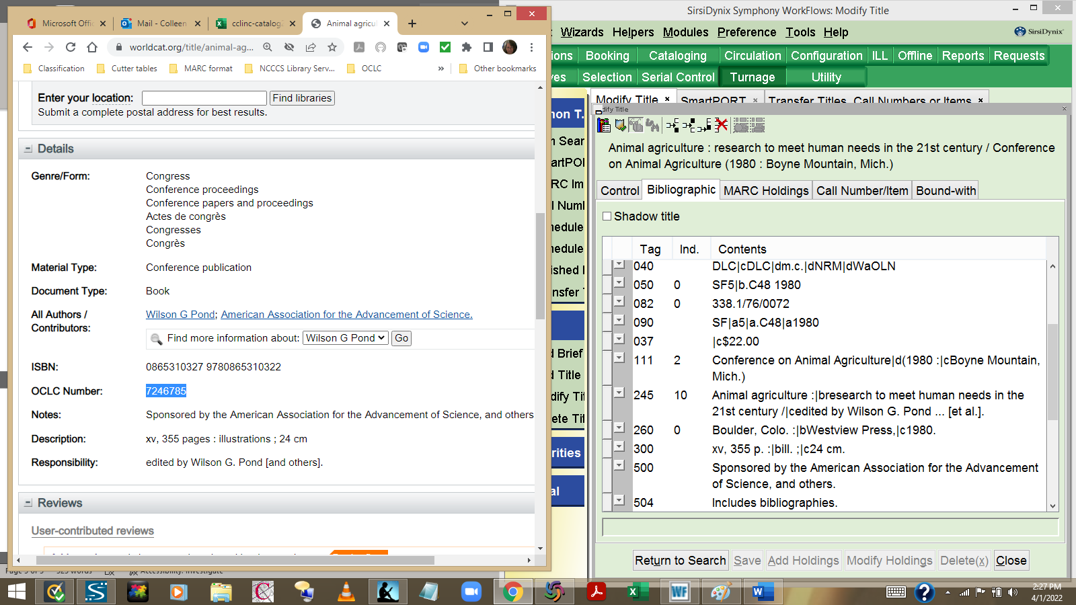
Be sure you verify the Description (aka pagination, # of volumes, etc.). If the record in WorldCat matches the record in WorkFlows, then you highlight and use the CTRL-C command to copy the OCLC# (or you can highlight the #, right click on it, and select Copy).

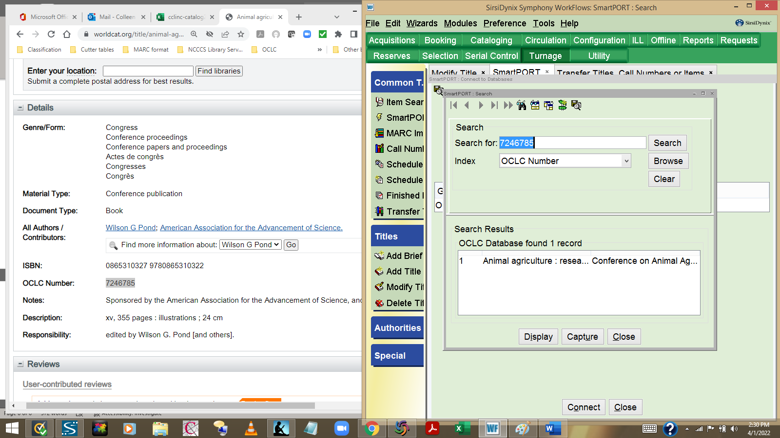
Use the CTRL-V command to paste the OCLC# in the SmartPort search window, then click on the Search button. Only one record will show up in your result list, because the OCLC# is unique. You will then highlight that title in the search results window and click on the Capture button. You can opt to click on Display first, but the reality is that you’ve already verified that the information in WorldCat matches the WorkFlows record.

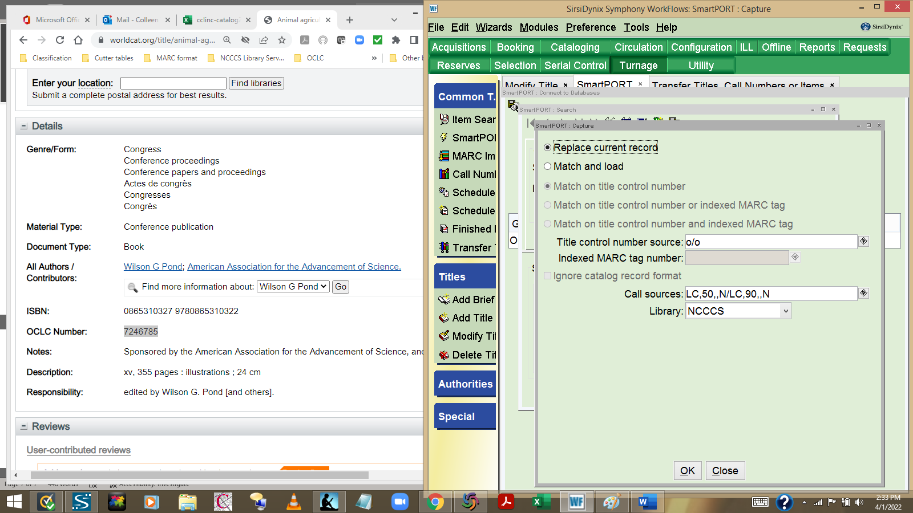
Change the SmartPort settings to Replace Current Record. Note: SmartPort will stay on this setting so long as you have the SmartPort wizard open. It will revert back to its original setting of Match and Load when you close the wizard. Click on the OK button.

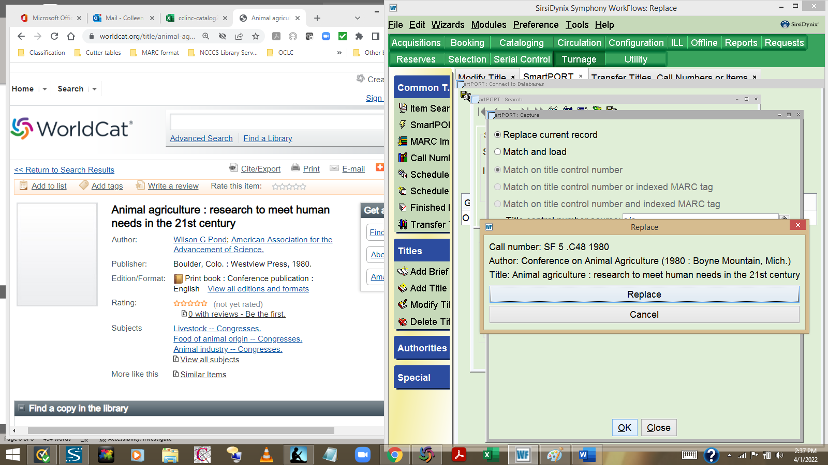
This window will pop up. PAY ATTENTION TO ITS CONTENT. This window tells you which title you’re getting ready to overlay/replace in WorkFlows. You want to be absolutely sure that it matches; you don’t want to accidentally replace the record with the wrong title! Click on the Replace button if it matches.

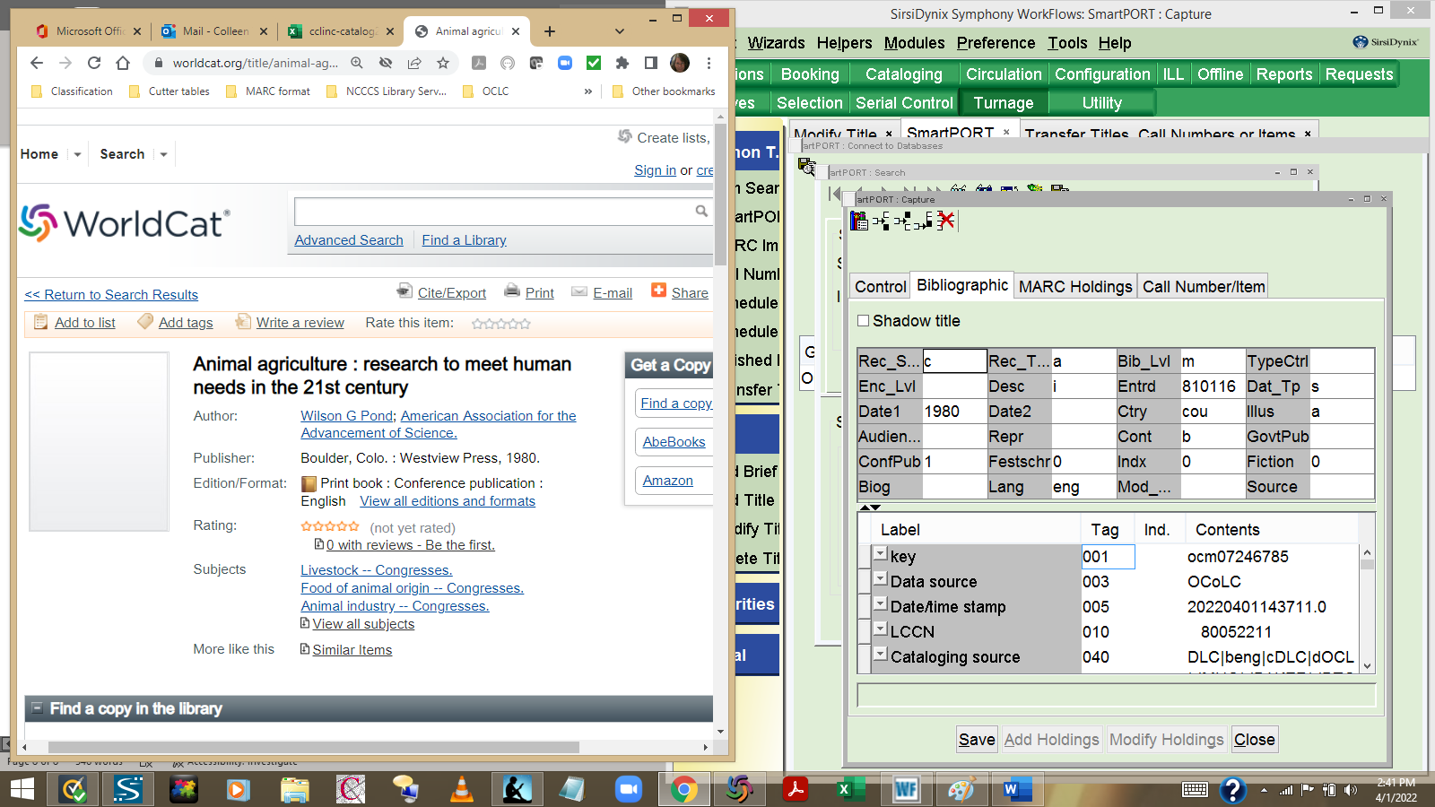
This is what you want to see… a clean MARC record. Just click on the Save and Close buttons.

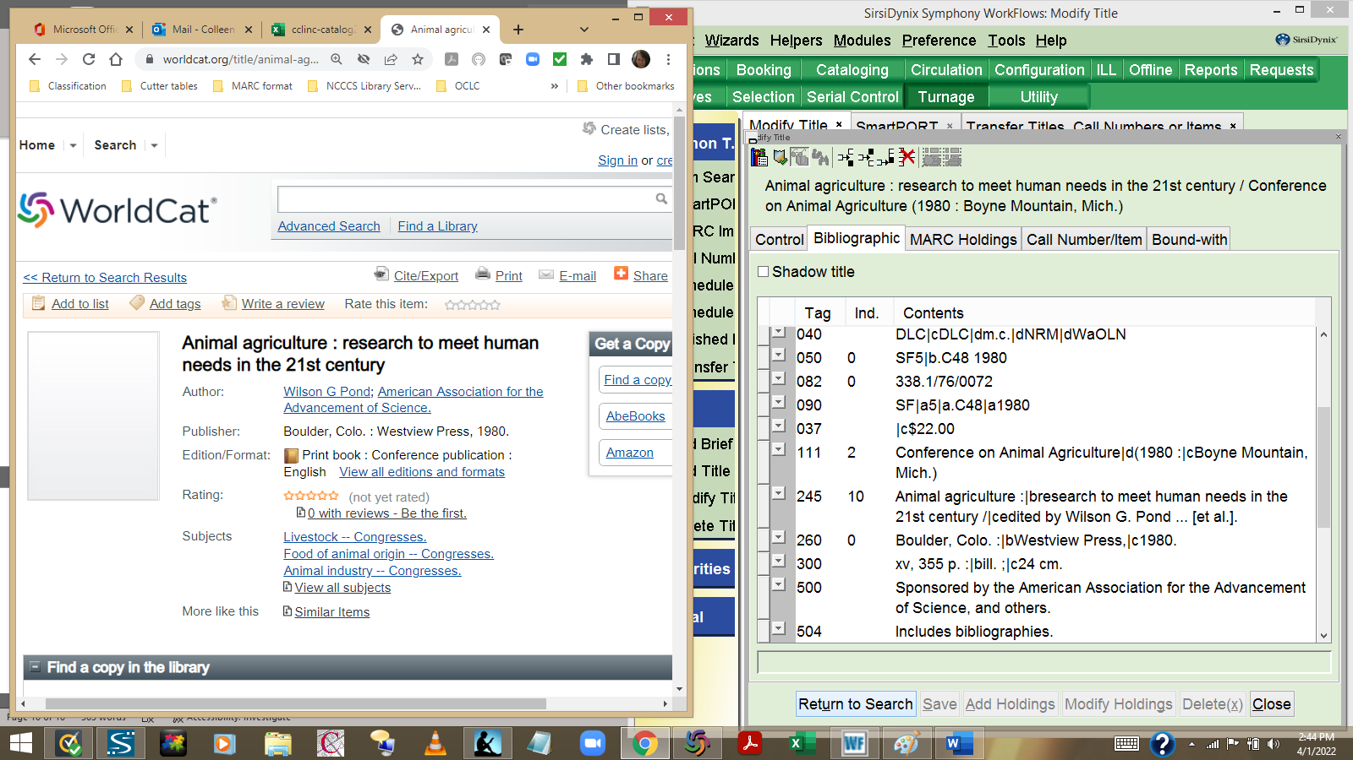
Now click on the Return to Search button in WorkFlows. This will return you to your search list. NOTE: The only differences you might experience are: 1. You get the duplicate title error message. If you get that message, just cancel out, then open the Transfer Wizard. You’ll want to refer to the Transfer Wizard instructions for more information. 2. If you see that the WorldCat title has a book jacket cover displayed then you can opt to copy/paste the cover image address in the MARC record. Instructions for that process can be found on the Library Services web page.

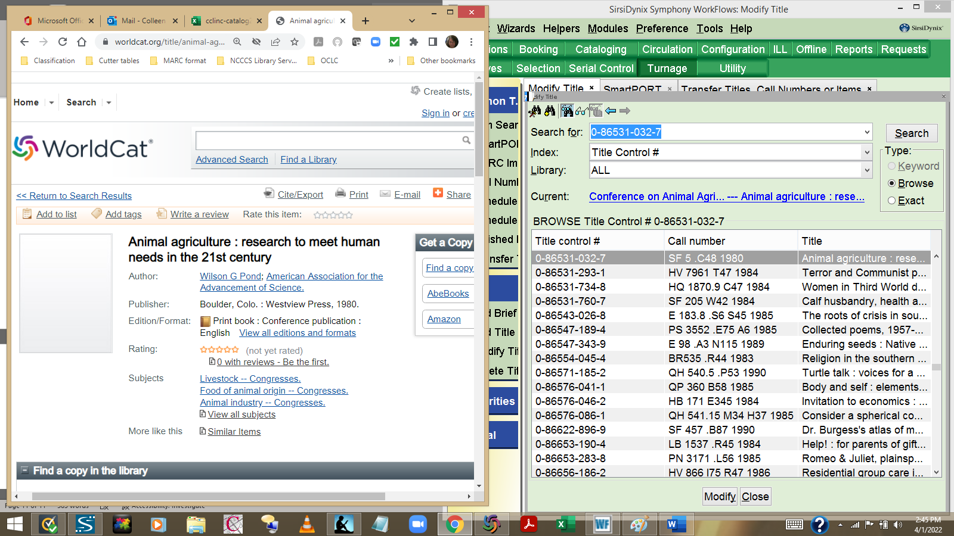
Note that the title control # displayed still shows the non-OCLC #. Double click on that # again.

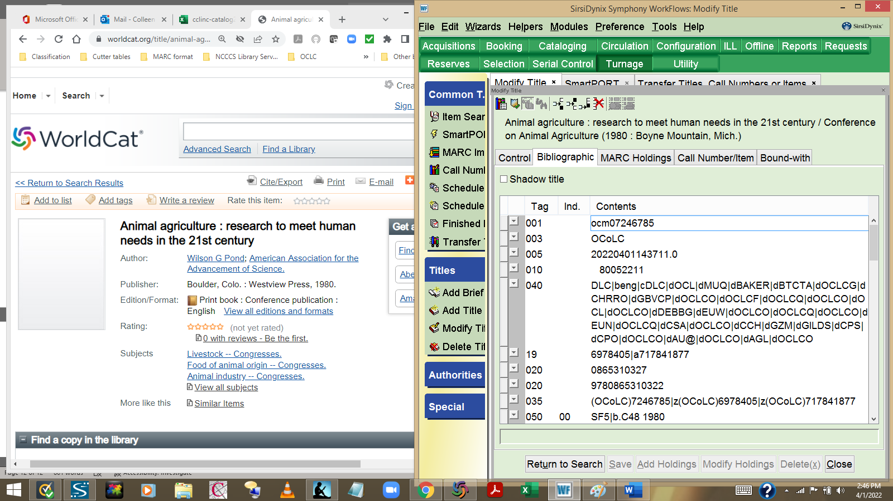
Note there is now an OCLC# displayed in the 001 field. Now click on the Return to Search button again.

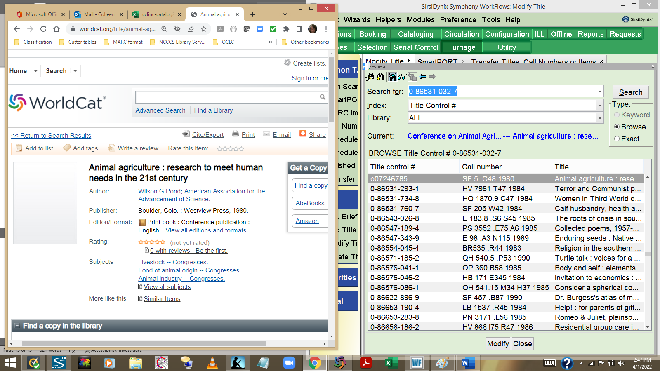
Now the OCLC # displays as the Title control #! This extra step is a good way to “final check” the process. You are now ready to move on to the next title in your list. Useful tip: I highlight finished titles on my Excel list in green. Then I use Excel’s “hide rows” feature so that at the end of my day I always have the next title I need to search for at the top of my spreadsheet. And if your library has weeded titles from its collection since your report was last run, just look for the next title you have on your WorkFlows list, then highlight and hide everything on your Excel spreadsheet up to that title, so that you know where to start. Also… WorkFlows displays only 20-30 titles at a time. You’ll want to be sure to note the last # displayed in WorkFlows, then enter that # in your search window so that WorkFlows pulls up the next batch of titles.

